Homework

Textbook “Infotech”

1. Unit 8 p. 37 B, p. 38 ex. C

37 B: 38 C:

1 inkjet printer 1 graphics

2 laser printer 2 resolution output

3 dotmatrix printer 3 hues

4 plotter printer 4 toner

5 imagesetter 5 scalable fonts

6 bar code

7 printing plates

8 intermediate

1. Unit 9 p. 42 A (vocabulary), pp.43-44 Text ex. A; p. 45 ex. B

42 A:

1. A blind student is using an adapter keyboard. He can visualize the letters on keyboard and use it to understand what is written.
2. A blind girl is using a screen magnifier, which enlarges the image of text or graphics on the display
3. A motor-impaired person is using a pneumatic switch(sip and puff) to operate the computer
4. A motor-impaired person is using an adapted keyboard to write the text on the computer

45 B:

1. textphone

2. on screen

3. embosser

4. alerts

5. reader

6. magnifier

7. braille

1. Unit 10 p.48 A, B, p.49 ex. A, B, p. 50 ex. C, ex. 4 A, p.51 ex 5

48 А:

1. C drive
2. Portable external hard drive
3. Magnetic tape drive
4. 3.5 inches and have the capacity of 800 KB to 2.8 MB (with a standard of 1.44 MB).

49 B:

1. F – hard drive spins faster than a floppy
2. T
3. F – hard drives can be partitioned to run separate operating system on the same disk
4. F - Seek time is the time taken for a hard disk controller to locate a specific piece of stored data.

Transfer rate is a standard metric that is used to measure the speed at which data or information travels from one location to another.

1. T

50 C:

1) d 2) a 3) b 4) e 5) c

ex. 4 A :

1) b 2) d 3) e 4) a 5) f 6) c

p.51 ex 5 :



1. Magnetism
2. Magnetic
3. Magnetized



4. fragmented

5. fragmentation

6. defragmenter

1. Unit 11 p.52 ex. 2 A



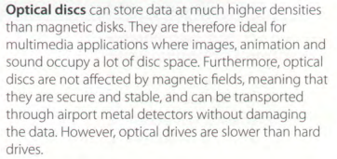



A DVD can be double-sided and dual layer, with a capacity of 17GB



A DVD burner is a DVD computer that records data on DVD.

A DVD recorder similar to a video cassette recorder

1. Unit 12 p. 57, ex. 1, ex. 2 B, ex. 58 C

p. 57, ex. 1 :

1) e 2) d 3) a 4) f 5) c 6) b

ex. 2 B :

1. Flash memory is a non-volatile memory chip used for storage and for transfering data between a personal computer (PC) and digital devices.
2. Ram is volatile , flash memory is non-volatile
3. Multi-level cell flash's potential for multiple voltage states decreases its manufacturing costs and has led to widespread use of the technology in cellphones, digital cameras, handheld music players and USB flash drives. MLC flash memory cards typically deliver a slower transfer speed and consume more power.
4. External hard drives are typically designed to store files and applications for longer than flash drives.
5. New U3 smart drives allow users to store both application and data
6. From 8MB to several GB
7. The memory Stick

ex. 58 C :

1. non-volatile 5. offloaded
2. rewritable 6. flash card reader
3. partitions 7. hybrid
4. to back up
5. Unit 13 p. 64 D, ex.65 E, p. 66 Help box

p. 64 D:

1. The user interface (UI) is the point at which human users interact with a computer, website or application.

2. Definition procedure is order of steps to be taken to make something happen, or how something is done

3. In computing, a command is a directive to a computer program to perform a specific task

4. Virtually any program or utility that helps programmers or users develop applications or maintain their computers can be called a tool

5. The background of the screen is called the desktop

6.A folder stored within another folder

7. launch program(Запуск/Створення програми)

8. A text listing of commands to be compiled into an executable computer program

p.65 E :

a) menu bar b) drop-down menu c) program icon

d) folder icon e) document icon f) window

g) hard drive icon h) scroll bar i) desktop j) dock

1. Unit 14 p.68 ex. 1 B, C, p.69 Word processing functions and icons, p.71 B

p.68 ex. 1 B:

bold text - жирний текст

italic text – курсив

hyperlink – гіперпосилання

Drawing tools - Інструменти для малювання

Insert picture – Вставити картинку

Footer – Нижній колонтитул

Inserted picture – Вставлене зображення

Increase indent – Збільшити відступ

Menu bar – Меню Рядок

Formatting Toolbar – Панель інструментів Форматування

Typeface – Шрифт

Standard toolbar – Стандартна панель інструментів

Header – Заголовок

p.68 ex. 1 С:

1. Toolbar, Formatting

2. typeface

3. Bold, Italic

4. indent

5. Header, Footer

p.69

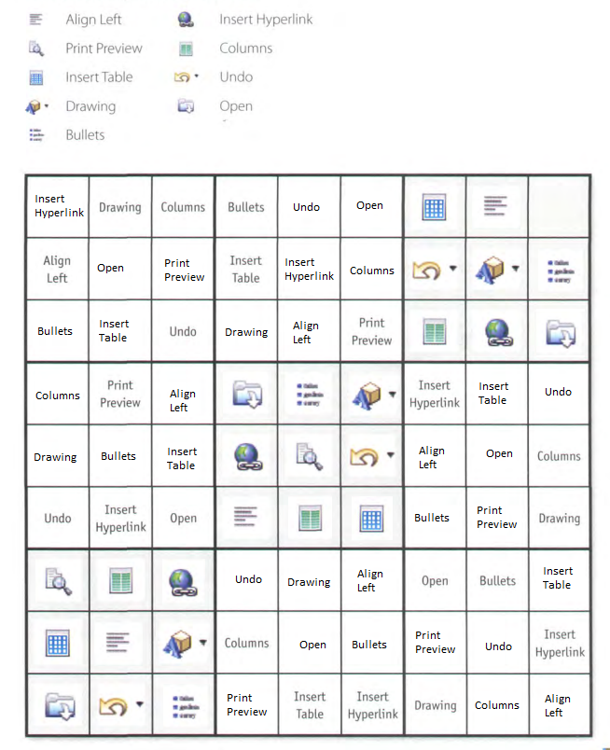

p.71 B:

1. select, drag

2. click

3. position

4. click, right-click

1. Unit 15 p.73 ex. B, E, p.74 A, B, p.76 Text „Databases“ ex. D, E, p. 77 Help box

p.73 ex. B:

a) column b) cell c) row

1. any text, numbers or formulas

2. Value of the spreadsheet are automatically recalculated

p.73 ex. E:

1. T

2. F – The value of cell B5 is the result of adding the value in cells B2, B3,B4

3. T

p.74 A :

1. Company 5. Price

2. Product 6. VAT

3. Description 7. Grand total

4. Quantity

p.74 B :

1. Dear Ms Atkinson

2. I am writing to

3. I am enclosing

4. We would be grateful if you could

5. Please contact us

6. Yours sincerely

p.76 ex. D :

1. store, organize and retrieve information from a database

2. fields

3. a separate piece of information

4. makink changes, adding new records or deleting old

5. its much faster to consult, is occupies much less space, records can be easily sorted, information can be easily updated, computer databases can be shared by a lot of users over a network

6. user-defined passwords and other security devices

p.76 E :

1. database 5. network

2. record 6. search

3. field 7. sort

4. relational 8. query